**PRACTICAL 01**

Creating Apache web server in ubuntu

**Update Your System**

Before installing any software, it's important to update your package lists to ensure you have the latest information about available packages.

sudo apt update

sudo apt upgrade

**Install Apache**

Apache is a free and open-source web server. To install it, use the following command:

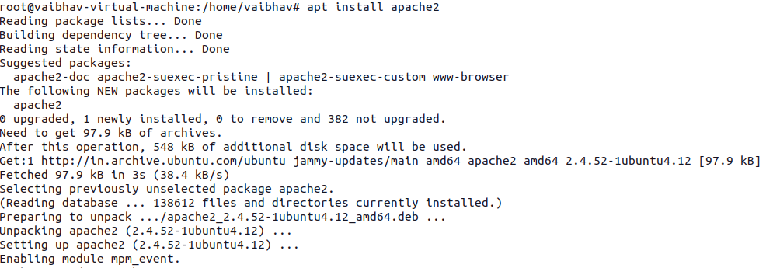

**Start and Enable Apache**

After installing Apache, you need to start the service and enable it to start automatically on boot.

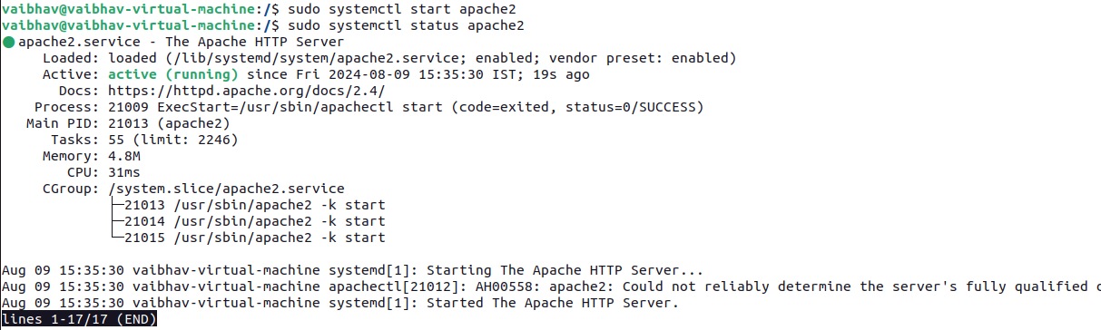

**Adjust the Firewall**

If you're using `ufw` (Uncomplicated Firewall) on Ubuntu, you need to allow traffic on HTTP (port 80) and, optionally, HTTPS (port 443).

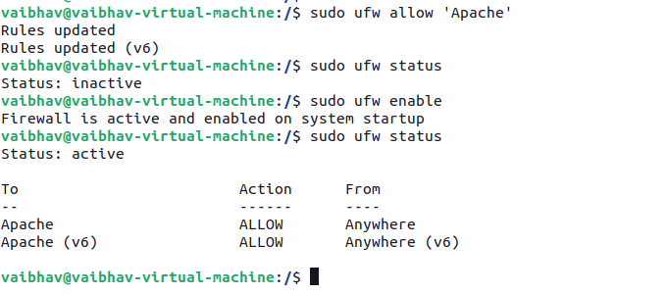

**Test Apache Installation**

To verify that Apache is running correctly, open your web browser and enter your server's IP address in the address bar. If you're doing this on your local machine, you can use localhost or 127.0.0.1.

http://localhost

**Set Up Your Web Directory**

By default, Apache serves files from the /var/www/html directory. You can place your website files in this directory to make them available on your web server.



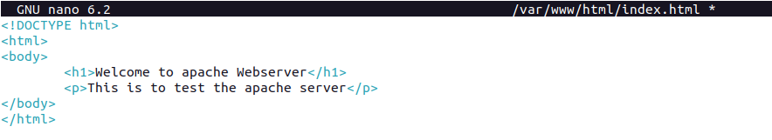

**Files Structure**

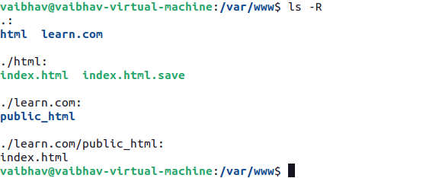

**Access Your Web Server**

Now, open your web browser again and go to your server's IP address or http://localhost. You should see the "Hello, World!" page that you just created.

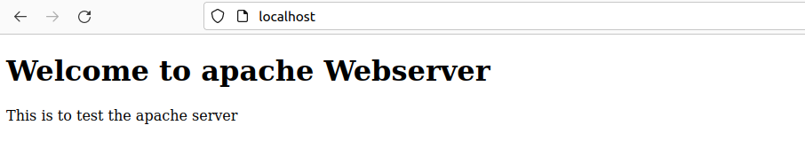

**Create a Directory for Your Website**: Create a directory to hold your website files. For example:



**Set Permissions**: Make sure Apache can read your website files:



**Create a Simple HTML Page**: Add a simple HTML file to test your configuration:



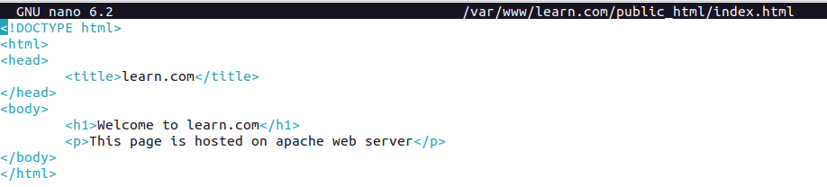

**Create a New Virtual Host File**: Create a configuration file for your domain:

Add the following configuration:

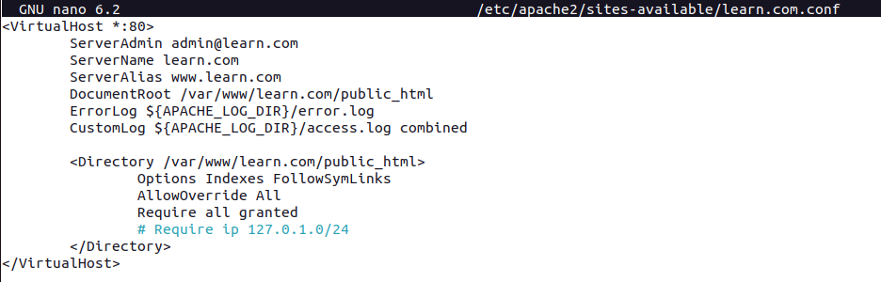

**Enable the Virtual Host**: Enable the new virtual host file:

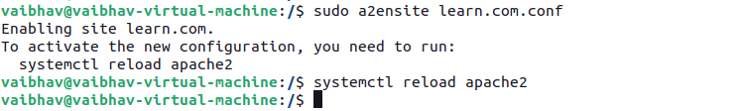

**Disable the Default Site** (optional): If you don't need the default Apache site, you can disable it:

sudo a2dissite 000-default.conf



**Restart Apache**: Apply the changes by restarting Apache:

sudo systemctl restart apache2

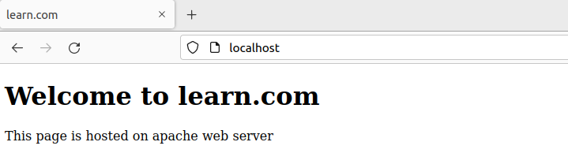

**Configure Local DNS to Access the Website by Name**

**Edit the Hosts File on Local Machines**

Each device on your local network needs to know that mywebsite.local corresponds to your server's IP address. You can achieve this by editing the hosts file on each device.



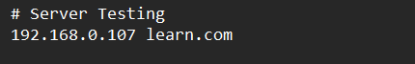

**Access the Website using website name**

Now, you should be able to open a web browser on any device within your local network and go to http://mywebsite.local to access your website.

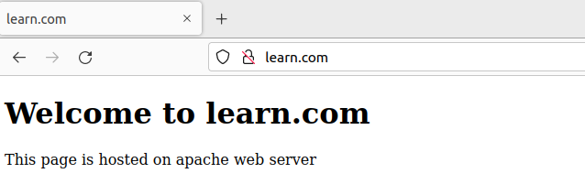

**On Windows:**

1. Open Notepad as an administrator.
2. Open the hosts file located at C:\Windows\System32\drivers\etc\hosts.

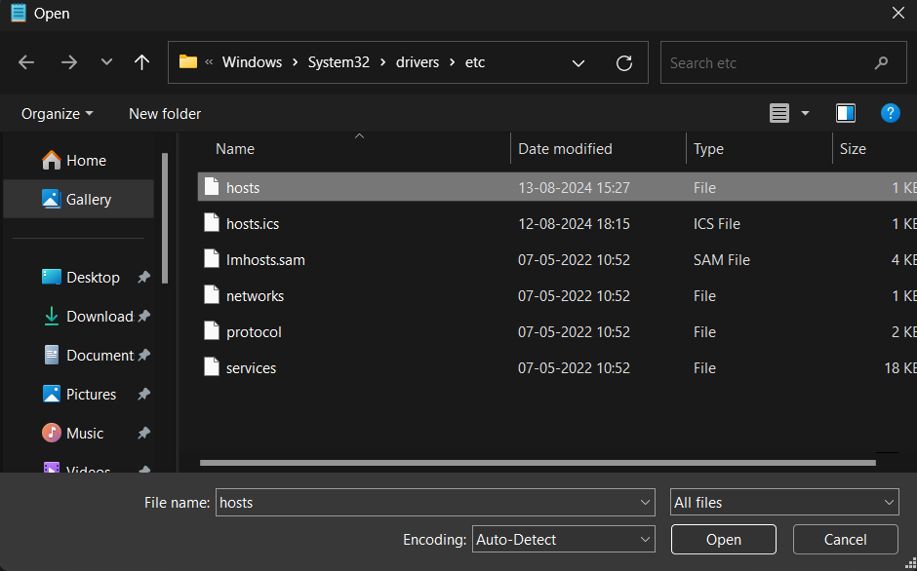

Add a line mapping mywebsite.local to the server's local IP address (e.g., 192.168.1.10):



**View the Log**:

This command continuously outputs new entries to the log as they happen, allowing you to monitor real-time access to your website.

